SECURE FILE SHARING SYSTEM REPORT
(Task-3 – Cyber Security Internship Project)

1. Introduction
This project focuses on building a Secure File Sharing Web Application that allows users to upload and download files safely. The primary objective is to ensure that all uploaded files are encrypted before storage and decrypted only during authorized downloads, thereby protecting sensitive data from unauthorized access.
This system simulates real-world secure data sharing requirements commonly used in healthcare, legal, and corporate environments.

2. Objectives
- To develop a secure web-based file sharing platform
- To implement AES-256 encryption for files at rest
- To ensure secure file upload and download operations
- To demonstrate basic cryptographic key management
- To follow secure coding and data protection best practices

3. Technology Stack
Component | Technology
Backend | Python Flask
Encryption | AES-256 (PyCryptodome)
Frontend | HTML with Embedded CSS
Key Management | Secure Random Key Generation
Tools | VS Code, Git, GitHub

4. System Architecture
The system follows a simple and secure architecture:
- User uploads a file via the web interface
- File is encrypted using AES-256 before storage
- Encrypted file is stored in the server’s upload directory
- User requests file download
- File is decrypted on the server
- Original file is securely downloaded by the user

5. Encryption & Security Implementation
Encryption Method
- AES-256 (Advanced Encryption Standard) using CBC mode
- A unique Initialization Vector (IV) is generated for each file
Key Management
- Encryption key is generated using a cryptographically secure random generator
- Key is stored securely in a separate secret.key file
- Key is never exposed to the frontend or hardcoded in the application
File Protection
- No plaintext files are stored on the server
- Only encrypted .enc files exist in the upload directory

6. Features Implemented
- Secure file upload functionality
- Automatic file encryption before storage
- Secure file download with on-the-fly decryption
- Clean and user-friendly web interface
- Proper error-free encryption and decryption flow

7. Testing & Validation
The application was tested using multiple file types to ensure:
- Files are correctly encrypted after upload
- Encrypted files cannot be read directly
- Downloaded files match the original content
- System handles multiple uploads correctly
All tests were successfully completed.

8. Security Best Practices Followed
- Use of strong encryption (AES-256)
- Secure cryptographic library (PyCryptodome)
- Separation of cryptographic logic
- No hardcoded secrets
- Controlled access to files

9. Screenshots & Demonstration
- File upload interface
- Encrypted files stored on server
- Successful file decryption and download
- Application execution recording
(Screenshots and screen recording attached separately)

10. Conclusion
The Secure File Sharing System successfully demonstrates how encryption can be used to protect sensitive data during storage and transfer. By implementing AES-256 encryption and secure key management, the system ensures confidentiality and data integrity. This project provides hands-on experience with cryptography, secure file handling, and real-world web application security concepts.

11. Future Enhancements
- User authentication and authorization
- Role-based access control
- Secure key vault integration
- HTTPS implementation
- Audit logging and monitoring
12. Evidences
- HTML frontend
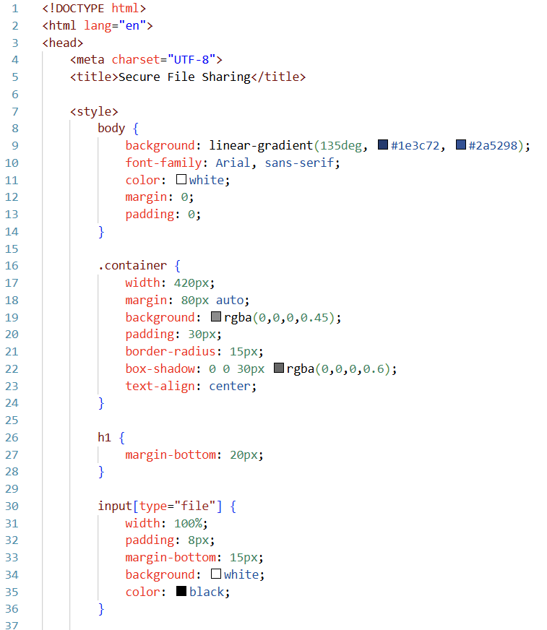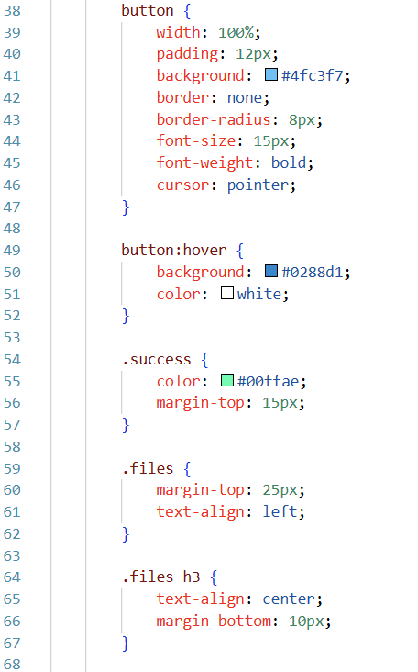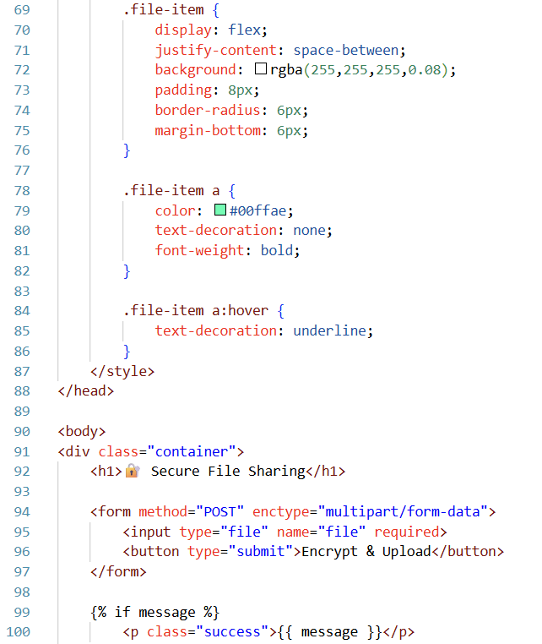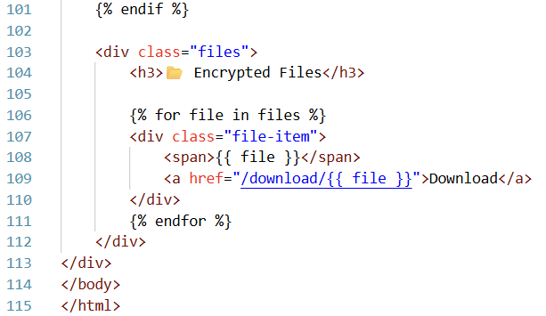
- App.py
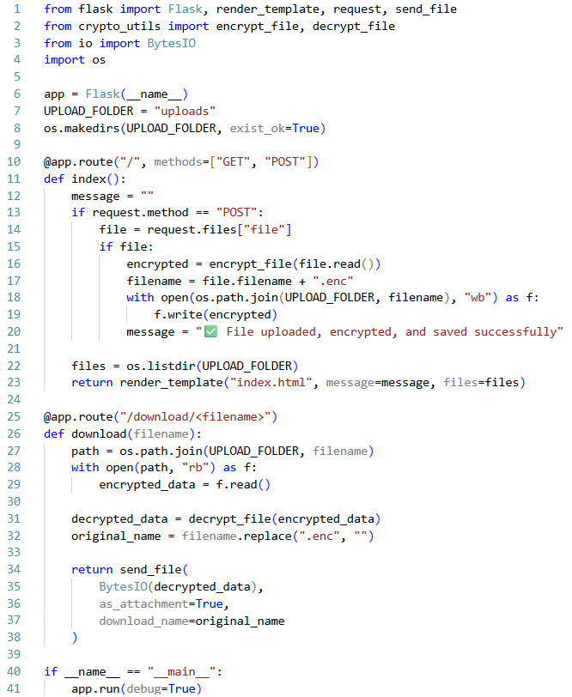
- Crypto_utils.py
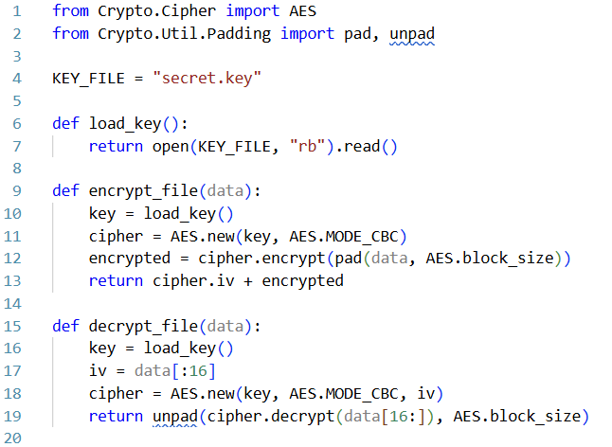

- Generate_key logic
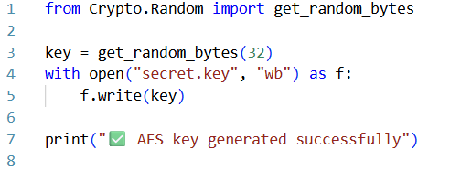
- Secret key created successfully
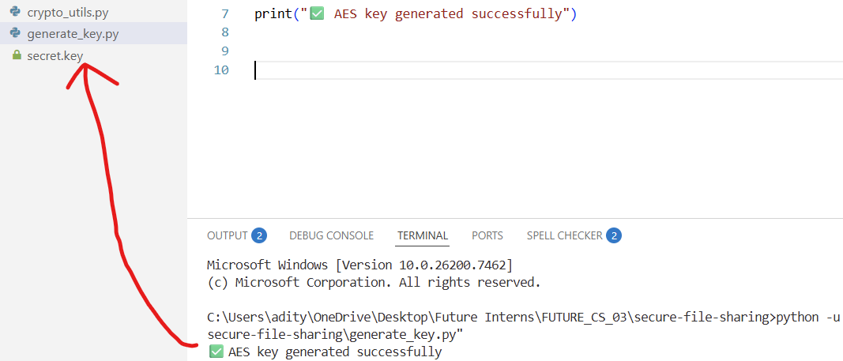
- Host active and running on 127.0.0.1:5000
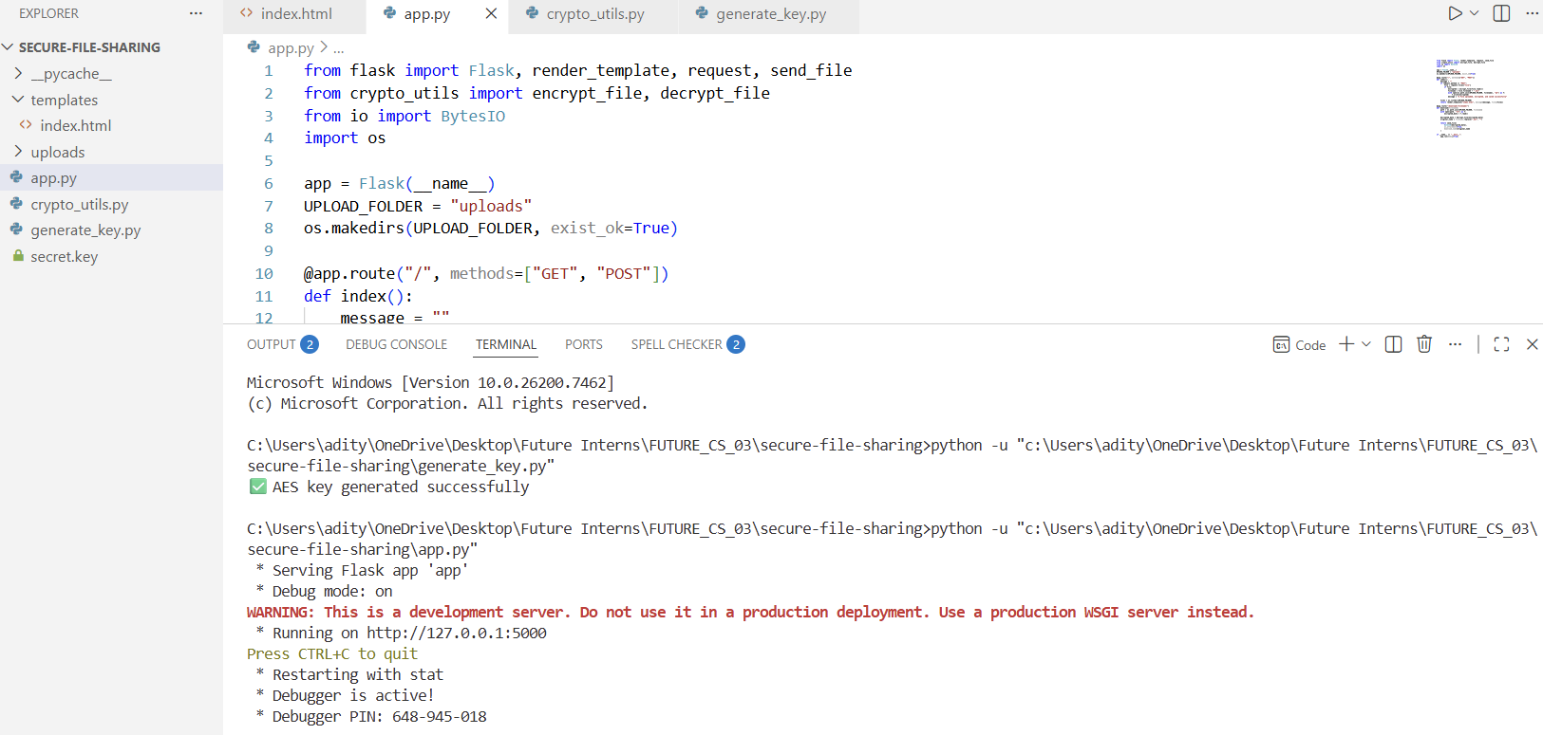
- User Interface
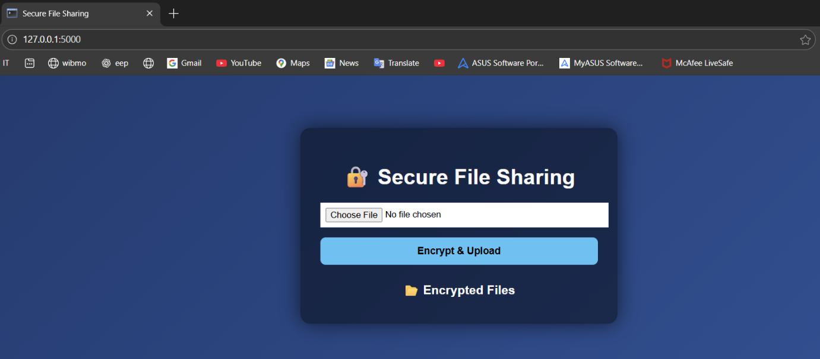
- File uploaded and encrypted successfully
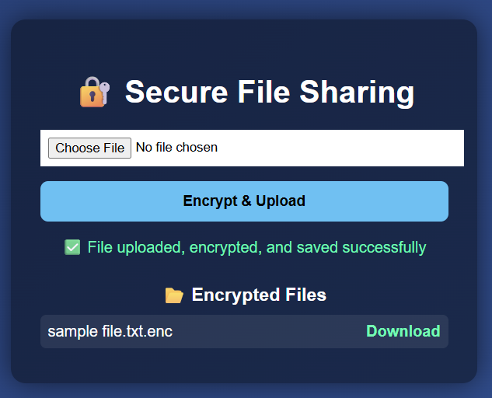
- Encrypted file
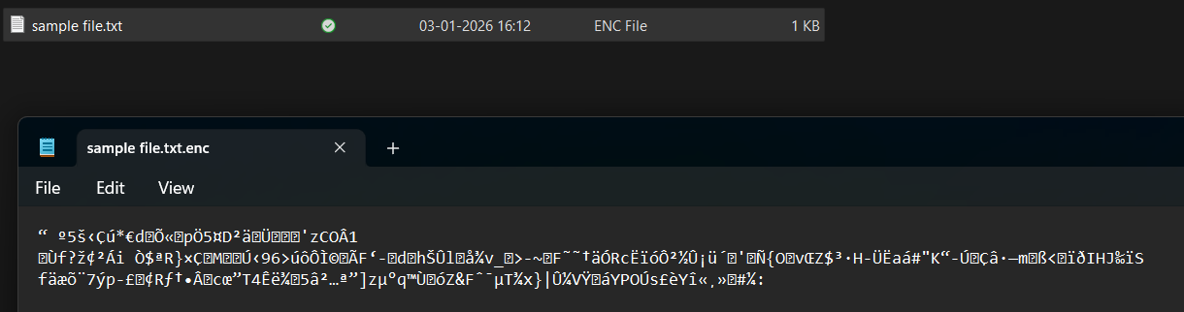
- Downloading decrypted file
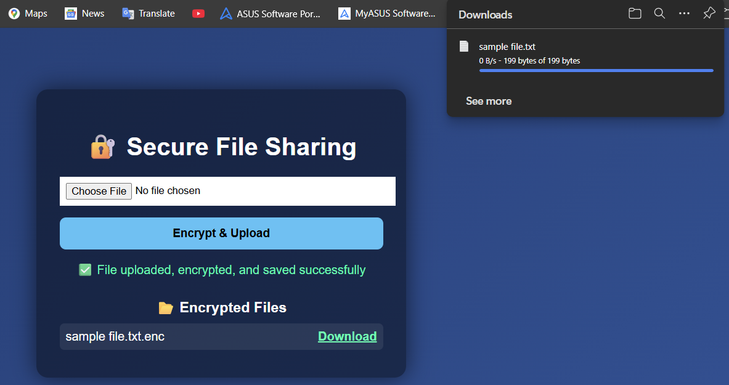
- Decrypted file
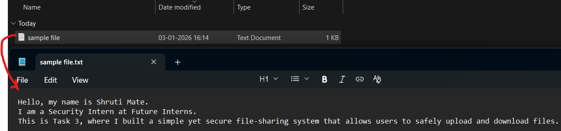
- GET and POST with response time.
